Grant Application Form – Organisations

Applicant Information
Name of Organisation: | __________________________________________________
Contact Person: | __________________________________________________
Address: | __________________________________________________
Phone Number: | __________________________________________________
Email Address: | __________________________________________________

Project Details
Project Title: | __________________________________________________
Project Description:

Objectives:
Target Audience:
Timeline:

Budget Total
Total cost of your project:
How much are you applying to Faringdon United Charity for:
Detailed breakdown of budget:

Please detail any other grants you have received or have applied for:

Impact
Expected Outcomes:

How will you monitor success?

Please state how your project meets the following charitable objectives:

to relieve either generally or individually persons resident in the Area of Benefit who are in conditions of need, hardship or distress.

to advance the education of boys and girls resident in the Area of Benefit who, in the opinion of the charity trustees, are in need of financial assistance.

Please demonstrate how your project will benefit residents from within our area of benefit (appendix a):

Supporting Documents to include:
- Constitution
- Annual accounts
- Safeguarding Policy
- Letters of Support
- Detailed Budget - include both income and expenditure

Privacy Statement:
In accordance with the General Data Protection Regulation (GDPR), we are committed to protecting and respecting your privacy. By completing this application form, you consent to the processing of your personal data by Faringdon United Charity for the purposes of assessing your grant application.
Your personal data will be stored securely and will only be accessed by authorised personnel. We will not share your data with third parties, unless required by law. You have the right to request access to, correction of, or deletion of your personal data at any time.
For more information on how we handle your data, please refer to our Privacy Policy available at www.faringdonunitedcharity.org.uk

Acknowledgment
Please confirm that:
- You have read and understand our grant policy
- You have read and understand our privacy statement
- That the information on this form is accurate to the best of your knowledge:

Signed:
Date:
Please return this form to: clerk@faringdonunitedcharity.org.uk
Or post to
Faringdon United Charity
All Saints' Church, Church Street, Faringdon, Oxfordshire, SN7 8AD

Appendix a.
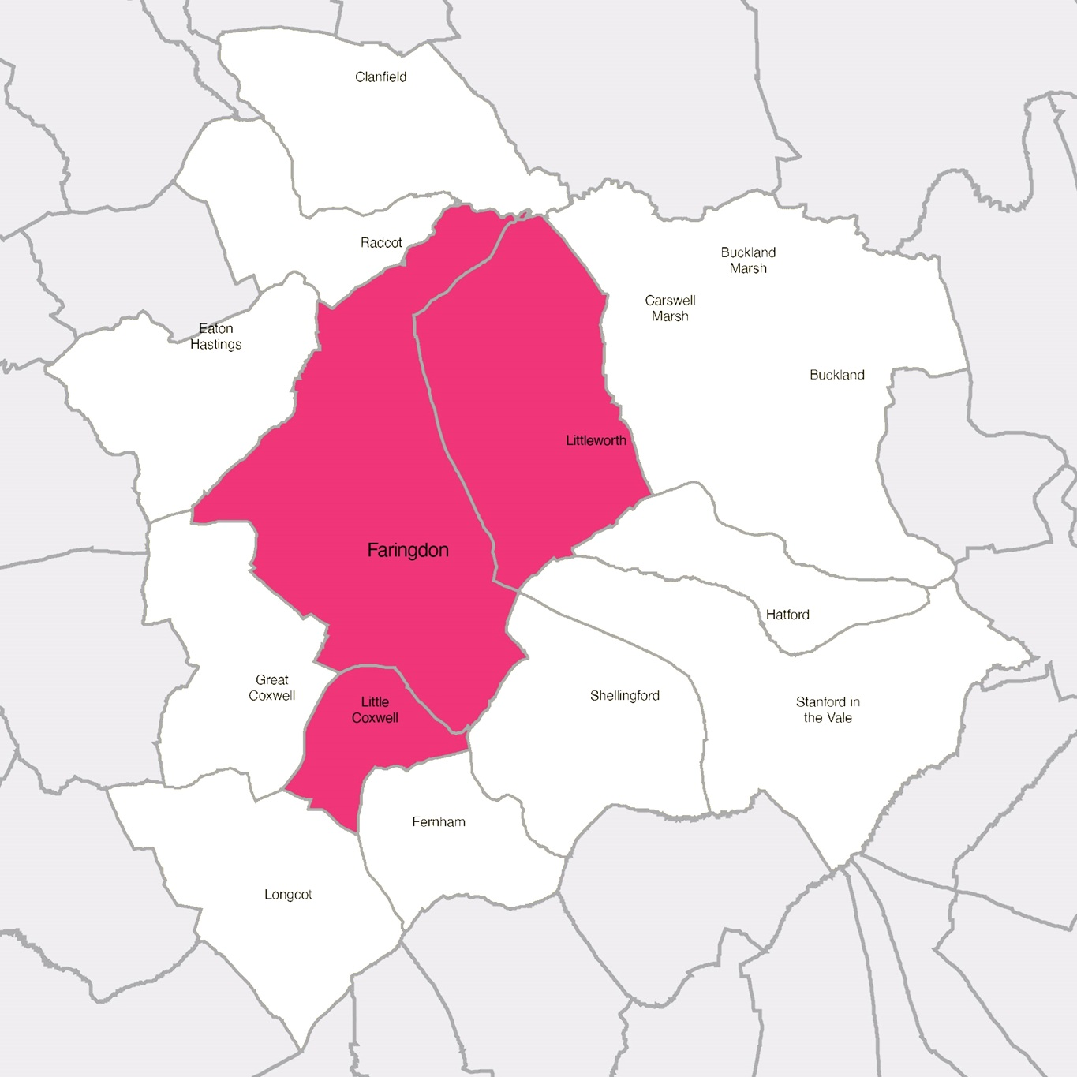

Pink = Area of Benefit (Faringdon, Littleworth, Little Coxwell)
For educational purposes, applications will be considered from pupils who attend, or Year 6 pupils planning to attend, Faringdon Community College, regardless of where they live.

