GRANT MAKING POLICY
- Purpose
  - The purpose of this policy is to set out the principles, criteria and processes that govern how Faringdon United Charity makes grants.
  - A grant is defined as a financial award the Charity makes from its funds to support charitable activities to registered charities, community groups, individuals and other bodies.

- Introduction
  - Faringdon United Charity is a charitable incorporated organisation (number 1186581) governed by a board of trustees
  - The area of benefit is Great Faringdon, Little Coxwell, Littleworth (see appendix 1)
  - The trustees ensure proper governance of the Charity’s grant-making in three ways.
- Through grant-making principles which ensure that the trustees are ultimately responsible for all grant making decisions.
- Through grant-making criteria which set out the activities the trustees wish to support in accordance with the objects in the Trust Deed.
- Through grant-making processes which set out how decisions are reached.

- Grant Making Principles
  - Applications from those who live in the area of benefit are eligible for consideration
  - Applications should be to support charitable activities to registered charities, community groups, individuals and other bodies.
  - The Board of Trustees are responsible for grant making decisions in line with the Charity’s objects.
  - The Board of Trustees may delegate decision-making responsibilities to its subcommittees within its framework of delegation.
  - The Board of Trustees reserves the right not to approve any nomination if, after due consideration, it determines that the resulting grant would not be charitable or falls outside of its objects and policies.
  - The award of a grant shall not create any entitlement to ongoing grants in future years. Separate applications will need to be submitted and considered on their merits.

- Grant Making Criteria
  - The aim of the grant making criteria is to provide clear information from the Board of Trustees to those individuals and organisations who want to apply for grants.
  - All grants must be in accordance with the following objects of the CIO:
- to relieve either generally or individually persons resident in the Area of Benefit who are in conditions of need, hardship or distress;
- to advance the education of boys and girls resident in the Area of Benefit who, in the opinion of the charity trustees, are in need of financial assistance.
  - Applications for individuals should be referred by the following professionals:
- social workers
- healthcare workers
- education providers
- the clergy
- advice services
  - Grants to individuals will be restricted to items, not cash.
  - Grants to registered charities, community groups and other organisations must be accompanied by:
- Evidence of a well-managed group, to include: constitution, track record, accounts and membership of a professional body where appropriate
- Financial sustainability and viability of group and/or project
- Evidence that funding has been sought from other sources and the level of match funding available
- Evidence of how the grant is in accordance with the charity objectives

  - General Conditions
- Grants are restricted by the area of benefit.
- There is no minimum or maximum amount for a grant application.
- Organisations are, normally, restricted to one grant application per year
- Grants should be spent both within the year and for the purpose for which they have been given.
- Grants cannot be made to cover money already spent.
- The charity reserves the right to request a copy of invoices and/or other documentation as evidence the expenditure has been incurred.
- Organisations are required to provide the charity with a written report, as agreed, to demonstrate how funds were expended.
- Grants can only be paid to an account in the name of the organisation, not to an individual’s bank account.
- If the organisation is dissolved the charity would expect any unspent part of the grant awarded to be reimbursed.
- Any unspent grant must be reimbursed to the charity
- Where funding has been awarded, a representative of the charity may visit the activity before, during or after the funding period.
- Grant Making processes
  - Stage One – carried out by charity clerk
Consider if the application is within the area of benefit and if so consider whether it can be dealt with by a sub-committee, head of large grants or requires the whole board to review it.

  - Stage Two
- Refer the application to the chair of the relevant trustee sub-committee who then decides what extra information is required and consults with other members of the committee;
Or
- Refer the application to the head of large grants who then decides what extra information is required and consults with other trustees
Or
- Refers the application to all trustees for consideration at a meeting or online

  - Stage Three
The responsible trustee advises the clerk on the action to be taken and this is recorded and carried out.

  - Stage Four
Where it is considered, appropriate there will be follow-up action and conditions to ensure grants to other charities and bodies have been used for the approved purpose.

- Policy Amendments
The Board of Trustees may vary the terms of this policy from time to time.

Approved by the Trustees on: 3rd April 2025

Appendix 1
Area of benefit
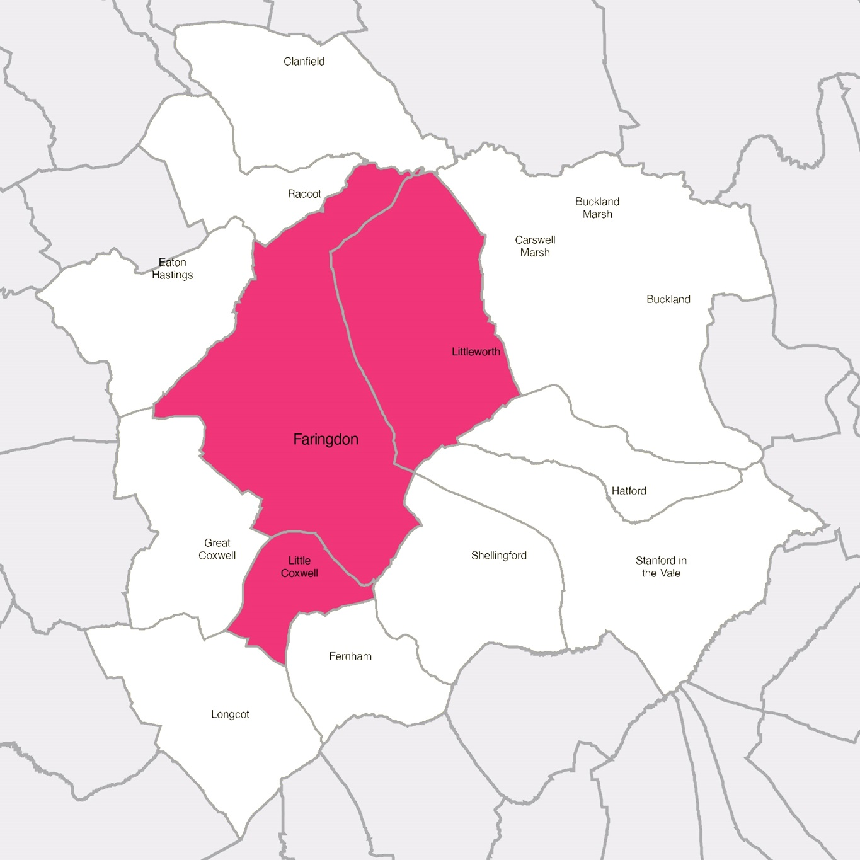
Pink = Area of Benefit (Faringdon, Littleworth, Little Coxwell)
For educational purposes, applications will be considered from pupils who attend, or Year 6 pupils planning to attend, Faringdon Community College, regardless of where they live.

